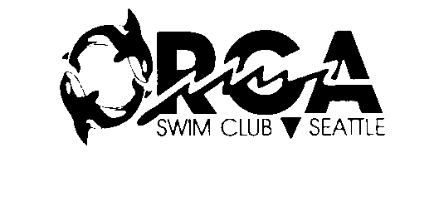
2002 MEMBERSHIP FORM
Name: ______________________________
I am a new member of the Orca Swim Team
I am a Renewing Member
**RENEWING MEMBERS: Be sure to note any changes to your e-mail address or mailing address below!
Check here only if you do NOT wish to receive mail or e-mail

E-Mail: ___________________________________________________________________
Address: ____________________________________________________
City, State, and Zip: ______________________________________________
Phone: ( )________________________
USMS Registration Number: ______________________
To register with U.S. Masters Swimming, call Cindy Martin at (206)366-8195 or e-mail her at ccmart@oz.net or find the registration form on the internet at: www.swimpna.org.
Birth date (optional): _________________
Donation to Team Enclosed ($15 suggested for calendar year 2002): ___________
Make checks payable to: Orca Swim Team
Send this form and your check to:
Attn: Membership
Orca Swim Team
PMB 869 1122 E Pike Street
Seattle WA 98122-3927
Remember to notify us of any changes in the above information so we know how to contact you. Send changes to the above address or to Derek Mullen, team secretary, at derekmullen@yahoo.com.

